Medical management questionnaire (preparation of the medical record)

This questionnaire must be completed as quickly as possible. A sheet must be filled out for each victim giving a precise description of the circumstances of the event and all the necessary listed information.

Victim's identification data (including the AMP patient number and the SINUS, SI-VIC tag):

Name of the physician or nurse who administered the questionnaire:

Date and time it was filled out:

Part 1: General medical management
1- Pathology and treatment:
Glasgow Coma Score:
Dominant pathologies:
Absolute Urgencies – AU Relative Urgencies – RU
burned
poisoned
blast
fracture.s
skull
thorax
abdomen
spine
polytraumatised
other chemical, biological, radiological, nuclear (CBRN) risk specify:

Diagnosis and treatment :
peripheral venous catheter
intraosteal route
tourniquet
intubated
Development:
improvement
stabilisation
aggravation (AU / RU / DECD)
2- Transport and destination/
medicalised
non-medicalised
destination:
service:
means of transport:
time:
Place to fill the follower card (Victim Assembly Area – VAA / Advanced Medical Post – AMP / triage) :
3- Medical surveillance and development :
clinical:
samples:
therapeutic:

Part 2: Radiological management (radiological evaluation sheet)
Required information list:
4- Acute radiation:
yes no
date and time:
type of radiation (gamma/X-ray, neutrons):
whole body and/or localised (part of body) :
estimated dose in gray (Gy):
diagram showing positioning with respect to the source.

5- Headaches and/or impaired consciousness:
yes no
date and time:

6- Early erythema:
yes no
location:
date and time:

7- Nausea and/or vomiting and/or diarrhoea:
yes no
date and time:

8- Hyperthermia:
yes no
date and time:

9- Guidance:
total estimated dose (gamma/X-ray + neutrons) < 1 Gy monitoring by:
total estimated dose (gamma/X-ray + neutrons) > 1 Gy Hospital

10- Associated chemical risk:
yes no
Chemical agents concerned:
11- External contamination:
yes no
if yes, indicate the contaminated zone
12- Emergency decontamination:
yes no
date and time:
13- Full decontamination performed:
yes no
date and time:
14- Residual external contamination:
yes no
detected or suspected radionuclides:
Diagram of the residual contamination
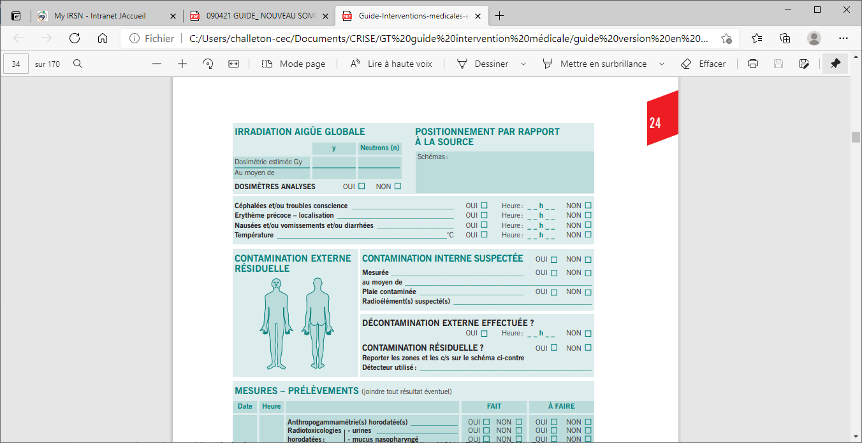

15- Internal contamination suspected:
yes no
16- Internal contamination:
measured by in-vivo radiation measurement: yes no radionuclides and activities measured:

suspected: yes no radionuclides :

17- Contaminated wound:
yes no
location

18- Measurements – samples:
Date | Time |  | DONE | TO DO
 |  | time-stamped radiation measurement | yes no | yes no
 |  | time-stamped urine radiotoxicology | yes no | yes no
 |  | time-stamped nostril sampling | yes no | yes no
 |  | skin appendage sampling indicating location (or time-stamped) | yes no | yes no
 |  | time-stamped blood samples | yes no | yes no
 |  | complete blood count (CBC), platelets, reticulocytes | yes no | yes no
 |  | haemostasis biochemistry enzymology | yes no | yes no
 |  | sodium-24 | yes no | yes no
 |  | phenotyping of the erythrocytes (red blood cells) | yes no | yes no
 |  | HLA class I and II typing | yes no | yes no
 |  | chromosomal aberrations | yes no | yes no

19- Internal contamination treatment | YES / NO | TIME | DOSAGE
Potassium iodide:  This treatment is administered as quickly as possible in cases of internal contamination by radioactive iodine. | oui non
Radiogardase® | oui non
Ca‑DTPA administered by slow IV injection or perfusion | oui non
Ca-DTPA by inhalation | oui non
DTPA on contaminated wound: one or more vials | oui non

